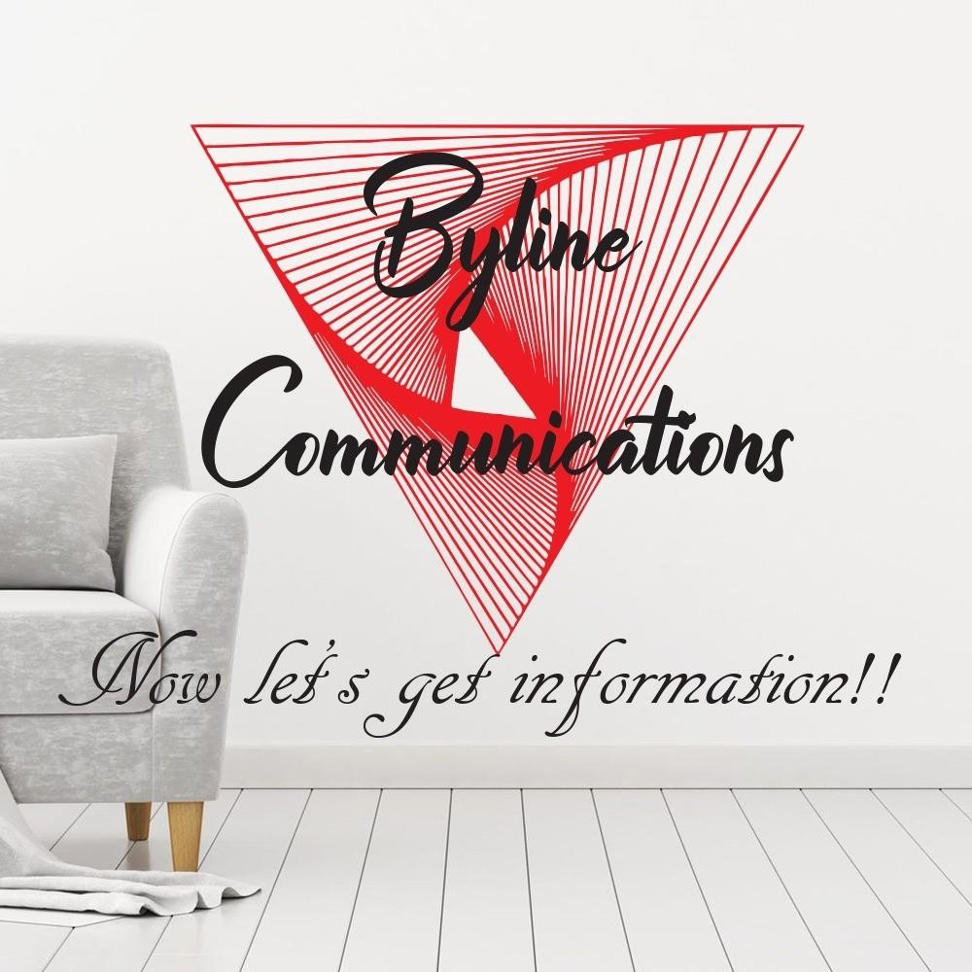

**BYLINE COMMUNICATIONS (PTY) LTD CONSULTANCY**

# FAKO STREET STADIUM AREA MASERU LESOTHO EMAIL: bylinecommunications19@yahoo.com

**Contact: Tokoloho Khutsoane (Ms.) +266 50296995 or**

**Mpho Fusi (Ms.) +266 58141284 or Seepheephe Mahao (Mr.) +266 62984141**

# BYLINE COMMUNICATIONS CONSULTANCY

**BUSINESS PROFILE**

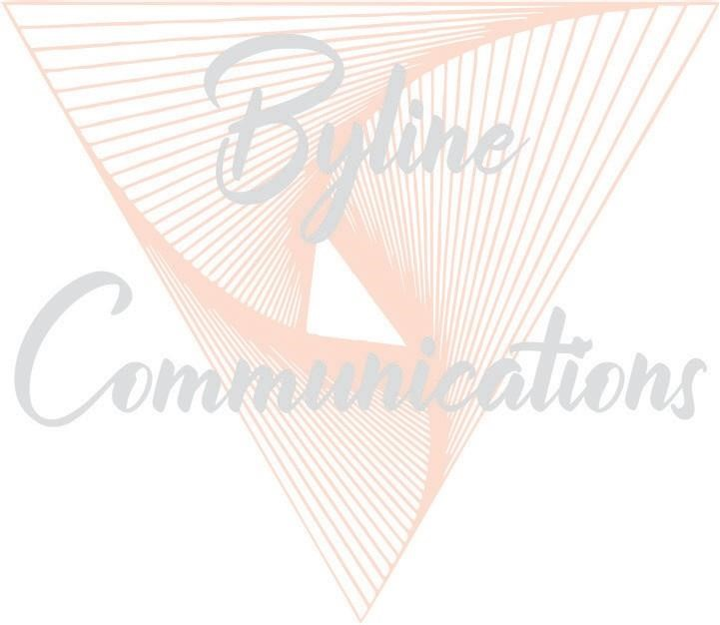

*This communication consultancy company’s business profile draws heavily on the business directors’ marketplace experience. The directors’ numerous years of expertise make this business unique.*

Byline Communications Consultancy, founded in 2019, is an integrated communications, marketing and events company that transcends the boundaries of conventional Public Relations and Marketing practices to bring multi-faceted and creative representation to clients. From entertainment to service and product corporations, Byline Communications works successfully with clients in researching their communication and marketing objectives and establishing effective communications campaigns to reach their targets and maximise their goals.

Byline Communications team is dedicated to approaching public relations in a pro-active and in the most spirited manner. The company delivers aggressive, personalised and senior-level service to all its clients. Whether through editorial placements or integrated personalised marketing programs, Byline Communications specialises specifically in entertainment, arts, culture, and leisure with focused planning, multimedia strategies and execution.



**2**

Through our relationships–extending from luxury brands and arts organisations to professional groups, charities and entertainment, we identify partnerships for our clients to elevate their market position with collaborations rooted in access and opportunity. These strategic alignments deliver communications messages directly to consumers and often cultivate media campaigns for additional exposure.

**Clients come to Byline Communications with their vision– Byline Communications builds the platform and campaign to publicise and reinforce that vision.**

**CONTENTS**

* **BUSINESS DESCRIPTION**
* **TARGET MARKET**
* **THE COMPETITION**
* **MARKETING STRATEGY**
* **MARKETING ASSUMPTIONS**
* **SALES STRATEGY AND TACTICS**
* **BILLING RATE**

## BUSINESS DESCRIPTION

Byline Communications is a full-service company, specializing in small and medium size publishing activities, advertising, specialized design activities up to creative arts and entertainment activities. It is a private company operating from Fako Street, Stadium Area, Maseru, Lesotho.

It relies heavily upon design, communications and marketing skills gained over a period of years in business-to-business marketing & communications.

**What are its services?**

In general, marketing planning, communications program planning and implementation. Implementation consists of the creation, production and distribution of marketing & communications which consist of all or any combination of the following:

**ADVERTISING, DESIGN AND PRODUCTION**

**Publications:**

* Publishing of newspapers, journals and periodicals
* Editing annual reports and other publications
* **Graphics & Multimedia Designs**

### Documentary Productions

Any topical issue/s; i.e.

* human trafficking,
* effects of climate change,
* COVID 19 pandemic and the homeless/street kids, • the life of a Prostitute in Maseru.
* Corporate Videos

### Radio and TV Commercials

* Advertising
* Advertising campaigns (television, radio & print)

### Broadcasting / streaming of live footage

* Business cards Motion picture, video and television activities
* Motion picture projection activities
* Sound recording and music publishing activities
* Radio broadcasting
* Television programming and broadcasting activities
* Wired telecommunications activities

**Photography**

### Web design and Social Media Animation

* Cartoons
* Infographic

### Management consultancy activities

* Market research and public opinion polling
* Educational support activities
* Communications Strategic planning
* Qualitative and Quantitative research

### Events and Promotion Management

* Conferences & seminars for film
* Entertainment activities
* Sales Promotion
* Product/Service Names

We will do all planning and as much of the creative writing as possible. We will always do the planning. We may do less of the creative writing as the business expands and requires more planning and project-management time.

**What Makes Byline Marketing Unique?**

We believe that a major factor which separates Byline Communications from other marketing & communications endeavours is our desire to communicate even the most sensitive social issues like; human trafficking, early child marriage, the life of a prostitute etc. We have extensive experience.

• ICT

* Software & Web Application Development
* Voice Over IP (VoIP) Solutions
* Access Control and CCTV Solutions
* Cloud and Shared Hosting Services
* Technology Integration Services
* Computer Hardware & Software (Sales & Services)

## TARGET MARKET

**What is Byline Communications’ target market and why?**

Byline Communications’ target market is to help develop its clients in the whole country of Lesotho. Opportunities to do business with larger companies and smaller firms will certainly be considered. In the proprietors’ years of experience, we have realised that few companies have formal marketing plans or marketing communications plans. Many have annual sales objectives which they may call “marketing plans”. The exceptions, in some instances, are companies that are divisions of larger corporations or those which already have a marketing communications company affiliation.

## THE COMPETITION

The competition consists of:

* Ad Agencies
* Communications services
* Freelance writers
* In-house communications departments

## MARKETING STRATEGY

**How has Byline Communications positioned itself?**

Byline Communications has positioned itself to be the primarily a niche-market service supplier. Most established marketing communications companies, because of their overhead, cannot afford to spend time on the lower end of our annual sales volume objective. The proprietors have an extremely varied background in terms of different kinds of clients. This experience encompasses virtually most marketing venues, communications and media. Byline Communications represents an excellent match for the small-sized to medium-sized clients who do not have a large enough budget to attract communications agency with equal experience and expertise.

**What is the nature of the target client?**

Many of the target companies are entrepreneurial in nature. They are well familiar with their business situation. If they are successful, they figure they are doing just fine and do not want or need advertising.

To a degree, they are right. They might be selling in a niche market. Their customers and prospects might also be smaller in number. The nature of their product(s) might be self-localising, and time might help define their geographical marketing area, hence its size. Almost everyone has local competition, however.

**What makes Byline Marketing different?**

Although we are a relatively new marketing & communications company, we possess enough experience working with our target market firms. Byline Communications is well versed in many manufacturing processes so it understands how products are manufactured and marketed. We are familiar with the various kinds of sales organisations used by local companies and their distribution systems and the methods behind them. Although the thinking of business-to-business communications consultancy is changing, marketing and the resultant media commissions still represent a major revenue component. Many of our business targets are unattractive to competitors because they might never be significant trade media players.

## MARKETING ASSUMPTIONS

Information on which potential clients have ad agencies is not readily available. This information must be obtained in order to reduce the number of prime prospects.

Many potential customers do not recognize the need for regular marketing & communications activity. This may suggest the availability of more per-project work. The target first contact, the Sales/Marketing Manager, is an extremely busy person and may be difficult to reach.

## SALES STRATEGY/TACTICS

**Sales Strategy**

Make cold contacts via letters of introduction followed by telephone calls. The approach will be made to the Marketing and/or Sales Manager where no Communications Manager can be identified.

Marketing/Sales Managers are extremely busy people who are responsible for the generation of sales materials where no Ad Manager exists. Some may rely upon an ad or PR agency.

If there is an Ad or Communications Manager, this person should be approached first. The existence of such a person usually means one of two situations: 1) The company already has an agency, or; 2) They have an in-house operation.

Whatever situation is uncovered, contact should still be made. They may be dissatisfied with their present agency or in the process of disbanding their in-house operation. Even with an in- house operation, they may still go outside for some services including creativity.

In addition to this formal effort, all opportunities resulting from networking and referrals must be followed up on.

**Sales Tactics**

The first-contact sales letter must introduce Byline Communications as the assistance the busy person needs to help simplify his or her busy life. It must identify with the prospects setting. It must back up Byline’s claim to be an experienced, versatile service partner. It must get across the fact that Byline will work on either an annual-fee basis or on a per-project basis. The letter will be stating that a telephone call will follow within one week of receipt of the letter. It is important to follow up as stated as this will be the first indicator of performance, that we are dependable.

## BILLING RATE

Billable time will include all planning, research, creative, administrative and travel time devoted exclusively to a given account or project.

**Annual Fee Billing Arrangement**

The fee may be paid in equal monthly installments which will be billed at the end of each month. A less-frequent payment schedule can be negotiated.

The Annual Fee does not include out-of-pocket expenses incurred in conjunction with the implementation of a client’s program. Such services as design, layout, typesetting, photography, illustration, printing and other outside services associated with the creation and production of a client’s program will be billed to the client with no agency markup. Supplier’s invoices will be provided to support such outside costs.

A budget, based on all known components, will be prepared, submitted and approved by the client prior to the beginning of the client’s program. Individual projects may be re-estimated during the program year, if circumstances require.

**Per Project Billing Arrangement**

Projects will be cost estimated by the agency and budget-approved by the client in advance.

**Out-Of-Pocket Expenses**

Out-of-pocket expenses, such as travel, lodging and meals will be evaluated on an individual basis and may be re-billed to the client.

**Vision**

To be the leading company that stimulates the economic growth of Lesotho through Communications and Marketing strategies tailored to our clients’ needs.

**Mission**

To integrate with the marketing departments of our client base in order to provide their respective organizations with a high quality, value added communications and marketing strategy that will assist them to grow financially.

**Values**

High Quality Global Standards

Professionalism

Strategic Partnerships

**Target Market**

Lesotho Business Sector

Schools

Associations / Societies

Non-Governmental Organizations

Lesotho Government

Our Designs so far

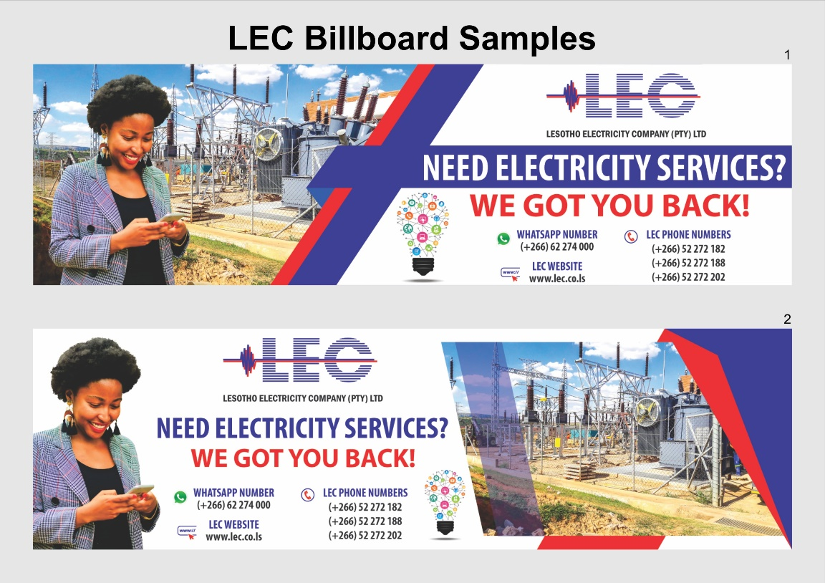

LEC Billboard designed by Byline Communications

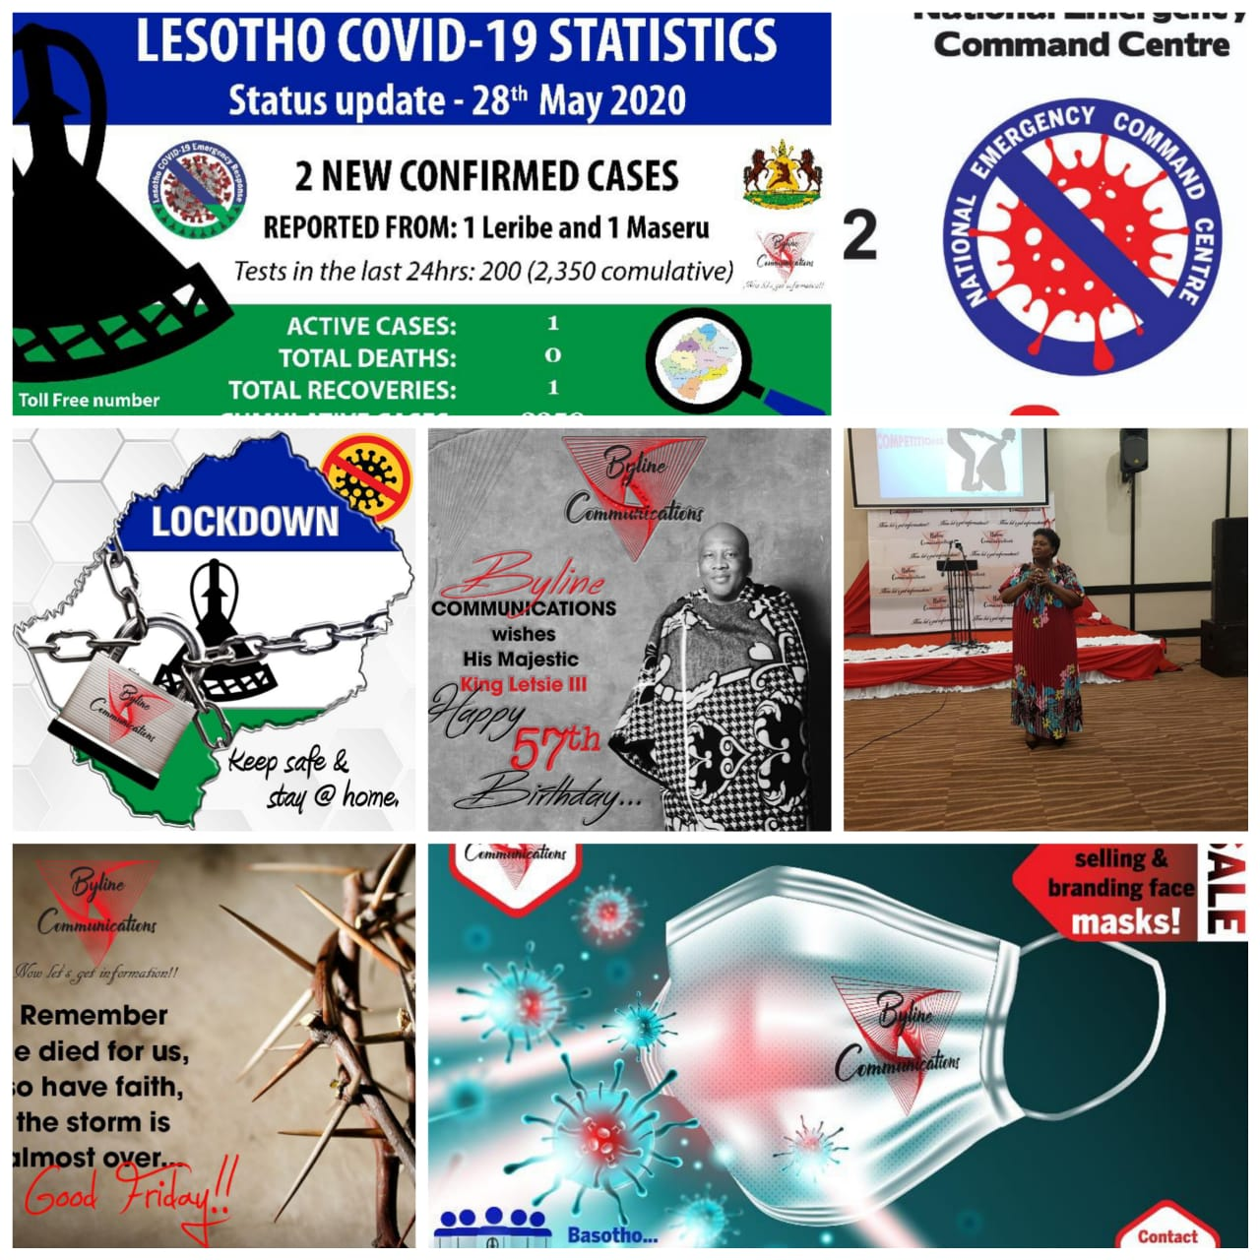





March 29th 2021

To whom it may concern

Recommendation Letter for Byline Communications

This serves to confirm that Byline Communications has provided services for the Media Institute of Southern Africa – Lesotho Chapter (MISA Lesotho). The company has been engaged by MISA Lesotho on numerous contracts to produce audio and video jingles, as well as designing campaign material including newspapers and newsletters.

During contracts with MISA Lesotho, Byline Communications has proved to be a professional company that delivers services impressively within set timeframes and in compliance with all contract terms.

I would undoubtedly recommend Byline Communications on media and communication services mentioned above for any organisation.

Sincerely,

Lekhetho Ntsukunyane 

National Director – MISA Lesotho



**30th, March 2021**

**Dear Sir/Madam,**

**To whom it may concern**

I am writing to recommend the services of Byline Communications (PTY)LTD for any communications work you might have. Byline Communications is a young company comprising of experts from different fields and I have had a very productive and educational period working with them.

They are patient, professional and always available to assist where possible, especially in 2020 during the COVID19 pandemic.

**Regards**

**Communications Manager**

**Lesotho Red Cross Society**

**Contact: +266 63791717**